- The April increase in employers' national insurance contributions will weaken the UK labour market, increasing unemployment. Sectors with the greatest reliance on lower paying roles, such as hospitality, art and recreation, and wholesale and retail, look highly vulnerable to job losses.
- To quantify the potential effects, we modelled the increase in employers' NICs. The results suggest the hike will cut employment by 55,000 and pay growth by 0.2ppts, and raise the unemployment rate by 0.2ppts. But we think the secondary threshold cut and simultaneous increase in the national living wage, at a time when corporate profitability is already weak, could yield nonlinear results. So the impact on jobs could be bigger than our modelling indicates.
- This year's large increase in labour costs is the latest in a series of cost pressures that have already pushed corporate profitability to a 23-year low. We're concerned about the ability and willingness of firms to absorb extra cost rises, particularly against a backdrop of soft demand.
- The large cut in the point at which firms start paying NICs will raise the cost of lower paid roles significantly, particularly given the national living wage will also rise sharply. We calculate the total cost of salary and NICs for a full-time worker on the living wage will increase by 44% between 2021-2025.
The labour market is a key source of uncertainty for the UK economy in 2025. We recently examined the key uncertainties and the challenges posed by data problems. Here, we look at how April's increases in the employers' national insurance contributions and national living wage might impact labour market prospects.
From the start of April, the rate of employer NICs will increase to 15% from 13.8%. The point at which firms start paying the tax will fall to £5,000 a year, from £9,100 a year now. The impact of these changes will be mitigated by the Employment Allowance rising to £10,000 from £5,000, with the eligibility threshold being removed. The national living wage will also increase in April, rising by 6.7% to £12.21 an hour.
Chart 1: Our modelling suggests the NICS rise will have a small impact on headcount and pay growth
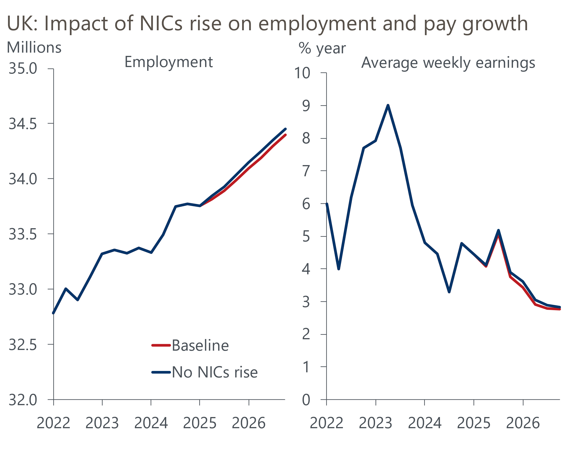
Sources: Oxford Economics, Haver Analytics

Our starting point for assessing the impact was a scenario developed on our Global Economic Model. We applied the pre-Budget national insurance rates and thresholds to our current baseline, imposing the shocks 'ex ante' to fully capture any second-round effects. This scenario suggests employment, pay growth, and corporate profits would be higher had NICs not been increased, while unemployment and inflation would be lower. However, the effects were relatively small. The peak impact on employment was 55,000 jobs in H1 2026 (Chart 1). Unemployment was 0.2ppts lower in our scenario, while pay growth was 0.2ppts higher.
But it's difficult to derive a precise estimate for the likely impact from a top-down model, because the combination of changes in NICs rates and thresholds is likely to give rise to nonlinearities. So we need to assess further evidence to come to a firmer conclusion.

Survey evidence points to lower headcount and – to a lesser extent – softer pay growth
Survey evidence is consistent with the transmission channels flagged by our scenario. Since the NICs increase was announced, the Bank of England has asked firms responding to its Decision Maker Panel how they planned to react. More than half expect to lower margins, raise prices, and reduce headcount. The proportion expecting to offer smaller pay rises was lower, but at nearly 40% was still high (Chart 2).
Chart 2: Most firms expect to lower headcount and pay growth because of the NICs rise
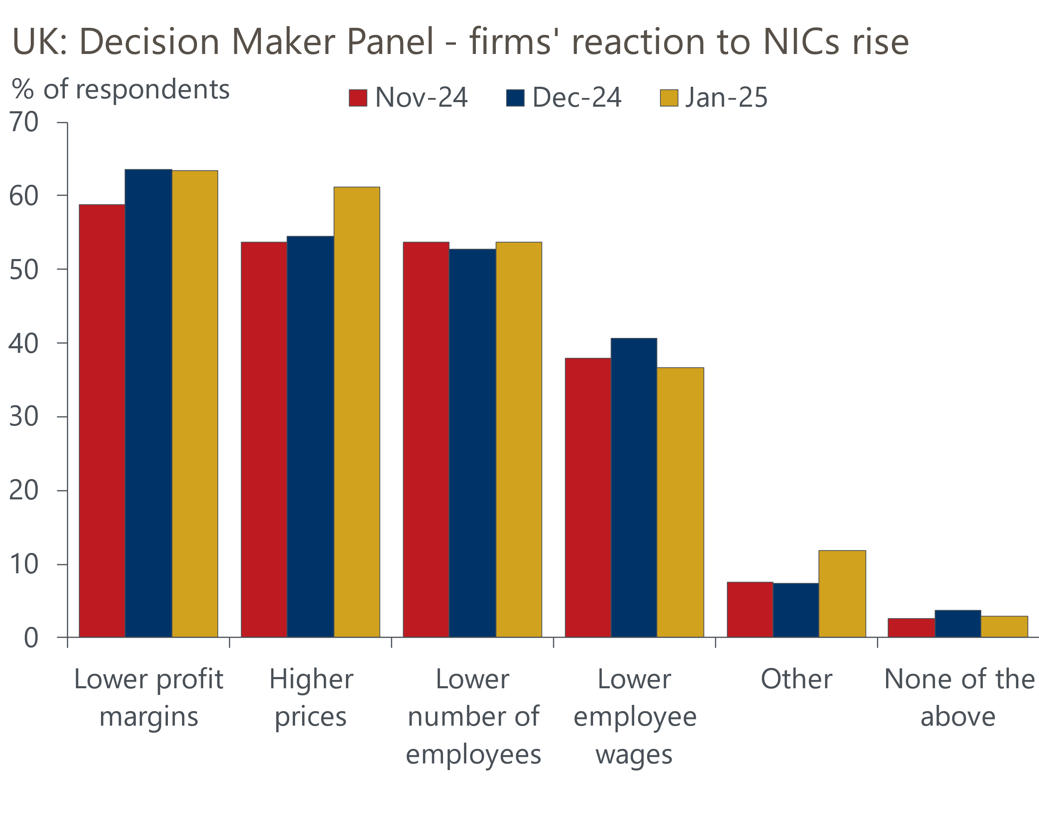
Source: Bank of England Decision Maker Panel
Business surveys tell a similar story on the likely impact on headcount. The CIPD's latest labour market outlook reported a softening in employment expectations, with firms set to recruit less and the share of respondents expecting to make redundancies increasing. These results continued the trend of cooling labour market conditions that was well established prior to the Budget.
Meanwhile, the latest CBI and BCC surveys reported a marked weakening in employment expectations across all sectors. Still, the scale of the fall shouldn't be exaggerated – based on past relationships, the average results from the two business organisations are consistent with modest year-on-year growth in the workforce jobs measure of employment in H1 2025 (Chart 3). This implies modest quarter-on-quarter declines in jobs in H1, but not a dramatic shakeout. The GfK survey suggests households have come to a similar conclusion on the likely impact of the NICs increase, with a modest increase in the balance of respondents anticipating that unemployment will rise over the coming year.
Chart 3: Employment expectations have softened, with survey results consistent with flat employment
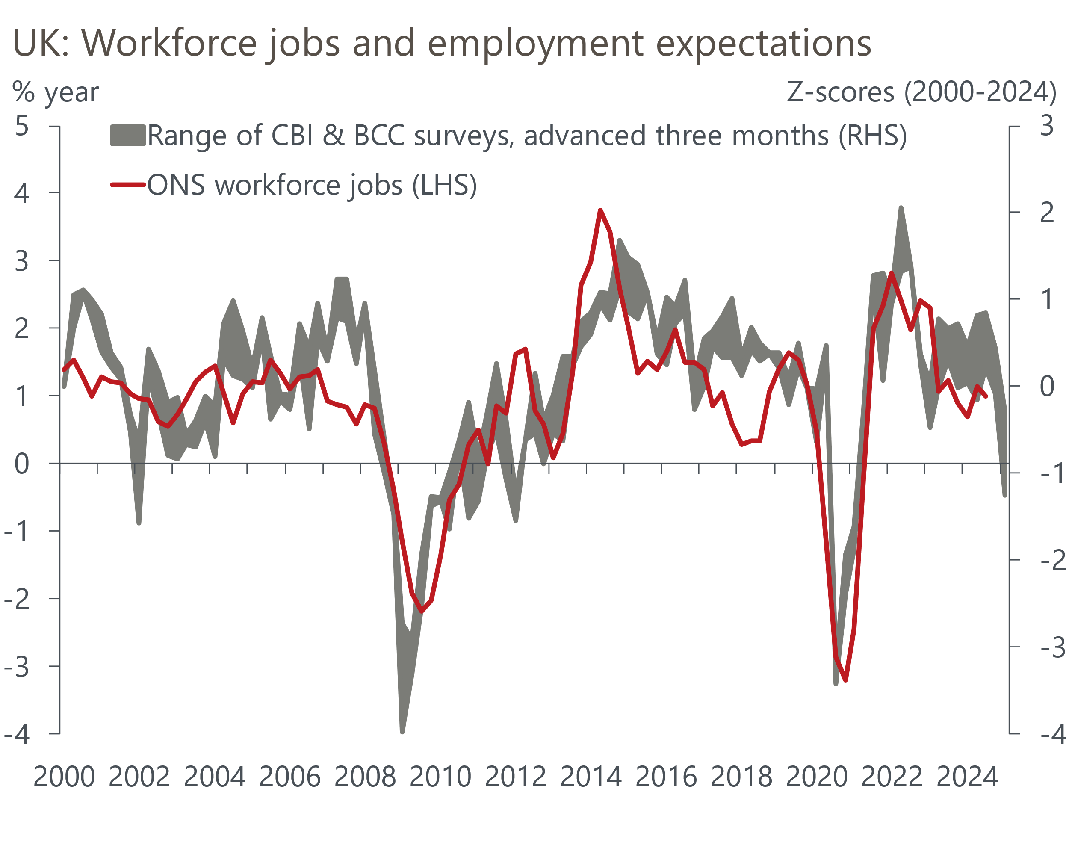
Source: Oxford Economics calculations using data from Haver Analytics

Large threshold change may cause a bigger hit to jobs
However, three factors lead us to think the NICs rise is likely to have a bigger impact on employment than our scenario suggests. First, the NICs increase will be accompanied by a 6.7% increase in the NLW. Second, a large part of the increase in tax revenue from higher NICs will come from lowering the threshold at which firms start paying the tax. Taken together, these factors imply a disproportionate impact on the cost of employing workers in lower-paying roles. Third, corporate profitability is already weak, raising the risk of a relatively large (non-linear) reaction to these extra cost pressures.
To demonstrate the scale of the first two issues, we calculated the change in the cost of employing a full-time worker across various points of the income distribution, as well as a worker being paid the NLW. Our base pay level is the April 2024 reading from the Office for National Statistics' Annual Survey of Hours and Earnings. For FY2025/26, the NLW is increased by 6.7%. As even a worker on the 10th percentile of the income distribution is already paid more than the NLW, we've assumed that every income decile receives a 5.1% pay increase in April 2025, in line with our forecast for year-on-year growth in average weekly earnings in Q2 2025.
The total cost (salary plus employers' NICs) of employing a worker on the national living wage who works 35 hours per week will rise by 10.6% in April (Chart 4). For a worker at the 10th percentile of the income distribution, the total cost will rise by 8.6% in April. The increases get progressively smaller moving up the pay distribution, but even at the 90th percentile we estimate the rise would be 7.2%.

Chart 4: The cost of employing lower paid workers will rise disproportionately
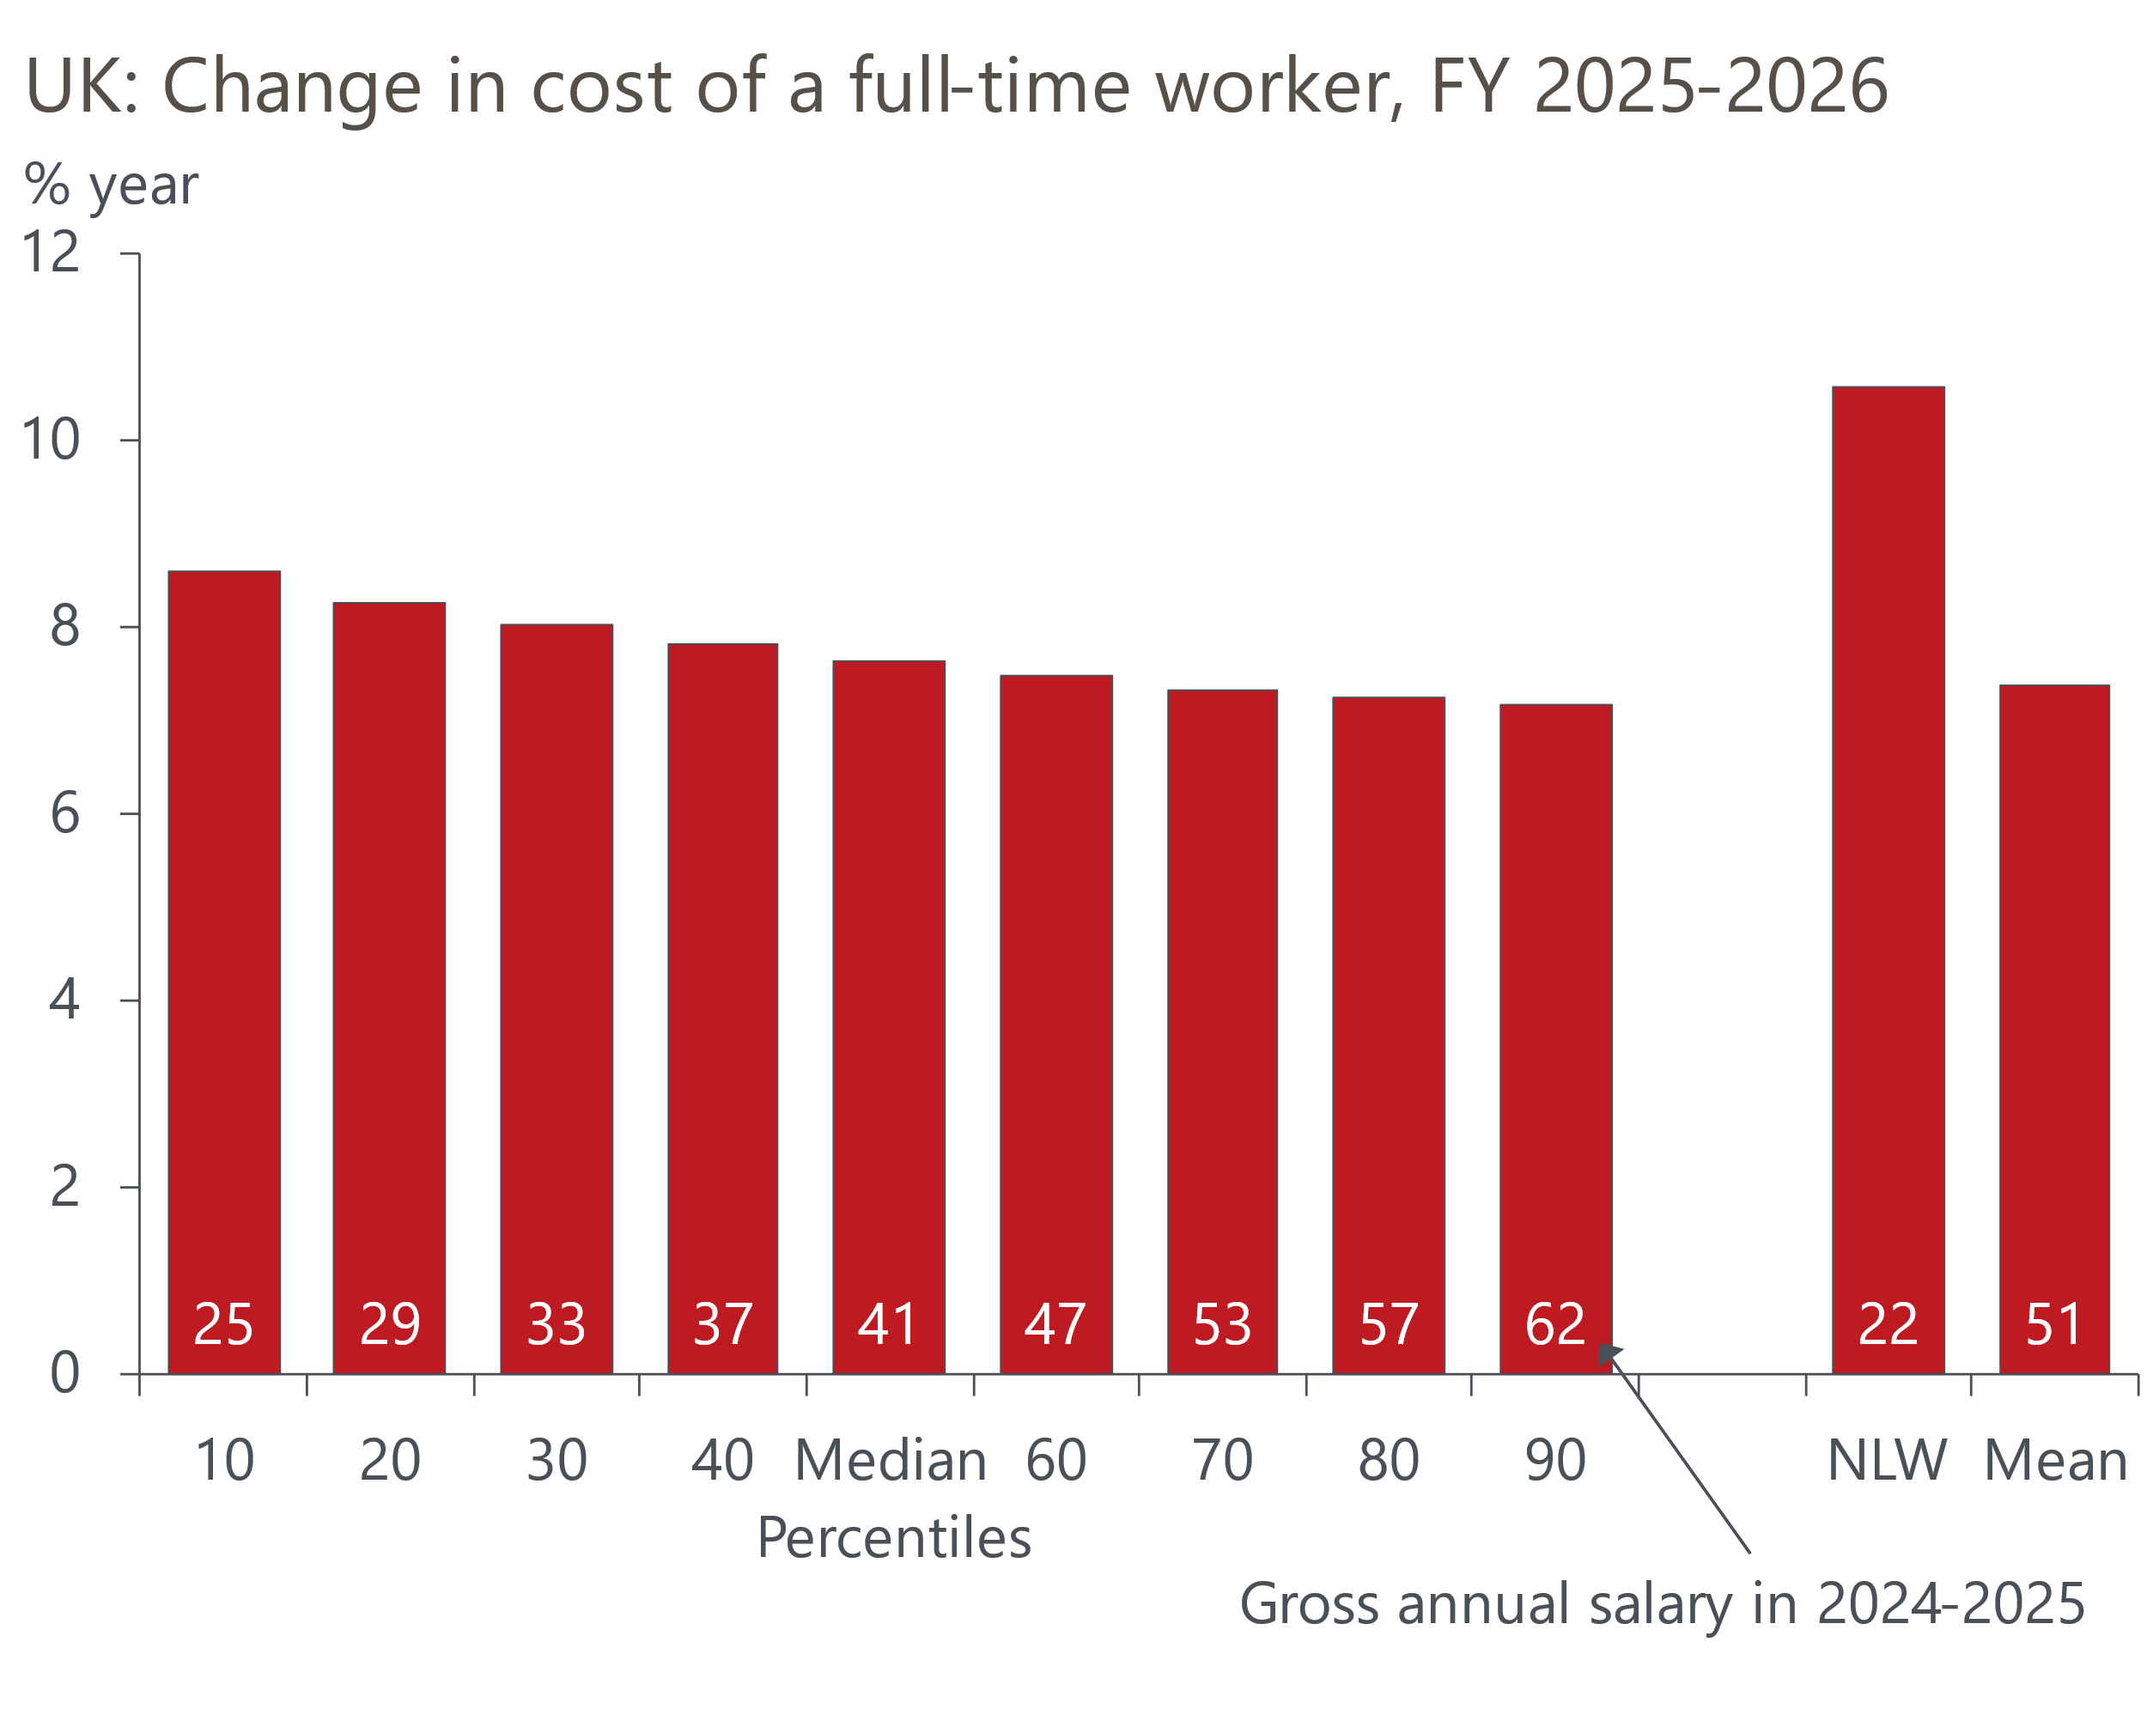
Source: Oxford Economics calculations using data from ONS ASHE
Furthermore, 2025's large cost increase comes on top of a series of big rises in recent years. We calculate that the total cost of salary and NICs for a full-time worker on the NLW will increase by 44% between 2021-2025. For a full-time worker on the median salary, the increase will be 29%.
Firms have also had to contend with substantial increases in their energy and debt servicing costs in this period. Though these non-labour cost pressures are now starting to fade, in Q4 the ratio of corporate profits to Gross Value Added at factor cost dropped to its lowest level since Q1 2001 (Chart 5).
Chart 5: Corporate profitability is at a 23-year low, even before the NICs rise
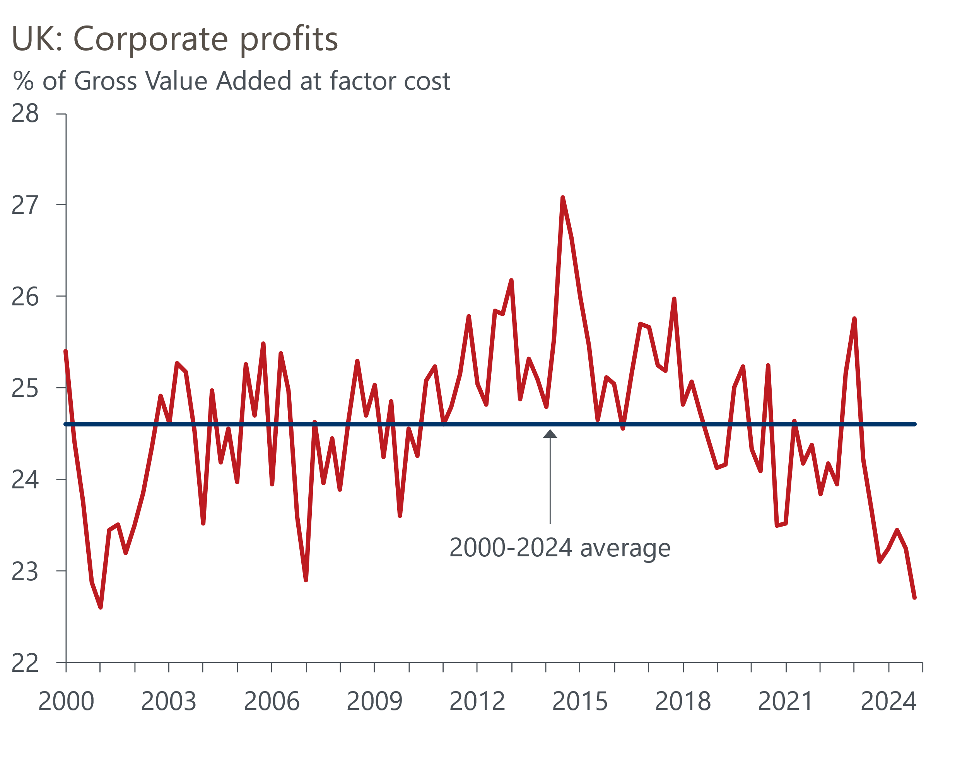
Source: Haver Analytics
Given the weakness in profitability, the ability of firms to keep absorbing large rises in labour costs is likely to wane. Firms have been keen to retain workers in recent years, with the widespread skills shortages experienced in 2022 fresh in the memory. But that motivation is also likely to fade the longer that demand remains weak. That's particularly the case for roles at the lower end of the pay distribution, for which less specialised skills are required. This suggests firms may put a greater focus on limiting the increase in their pay bill.

Parts of the services sector look most vulnerable
The wide disparity in impact across the pay distribution will also likely mean significant variation in the effects across sectors. A worker on the 25th percentile of the pay distribution for the accommodation and food sector earns around £9,000 per year, but for the utilities sector the 25th percentile is more than four times higher at £37,500 (Chart 6). The five sub-sectors with the greatest reliance on lower paying roles and, therefore, most vulnerable to the NICs and NLW impacts are all in the services sector, with the accommodation and food, art and recreation, other services, and wholesale and retail sectors looking most vulnerable.
Chart 6: Large parts of the services sector are heavily reliant on low paid roles
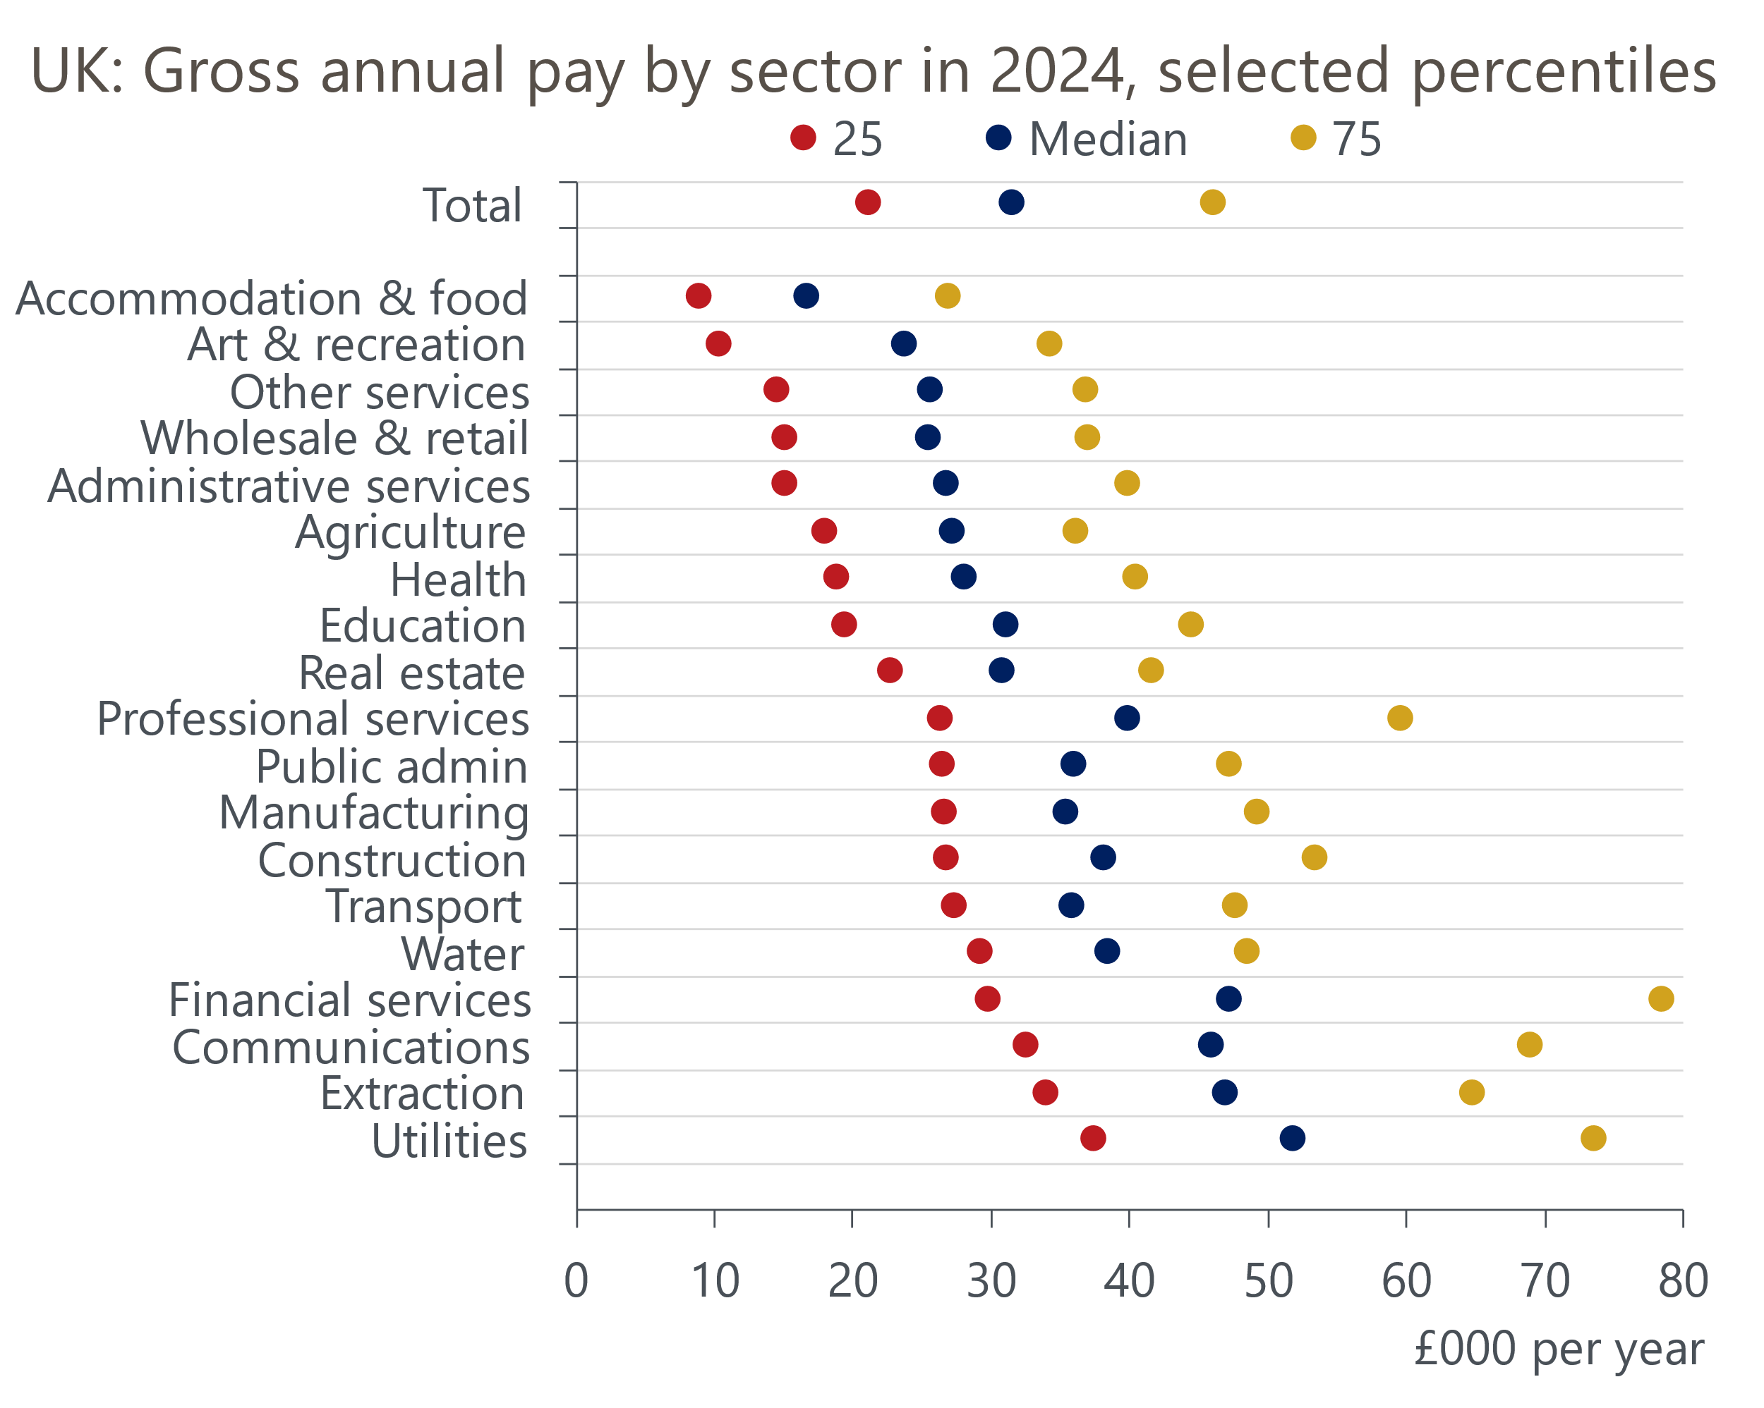
Source: ONS ASHE
These sectors are typically among the most labour-intensive. They are also more energy-intensive than the average, so have suffered disproportionately from the energy price shock. And they are strongly linked to consumer spending, a part of the economy that has underperformed in recent years. Indeed, since pandemic-related restrictions were removed, the performance of retail has been particularly soft.
So we view these sectors as being highly vulnerable to significant job losses. Consistent with this, the CBI's service sector survey suggests that firms' employment expectations are much weaker in consumer services than in business and professional services.
The impact across different sizes of firm may also be uneven. For the smallest firms, the changes to the employment allowance may mitigate the impact of the NICs increase, with the CIPD survey showing that more than half of small firms expect the increase in the employment allowance and removal of the eligibility threshold to reduce their costs (Chart 7).
Chart 7: Smaller firms expect the changes to the employment allowance to mitigate the NICs effect
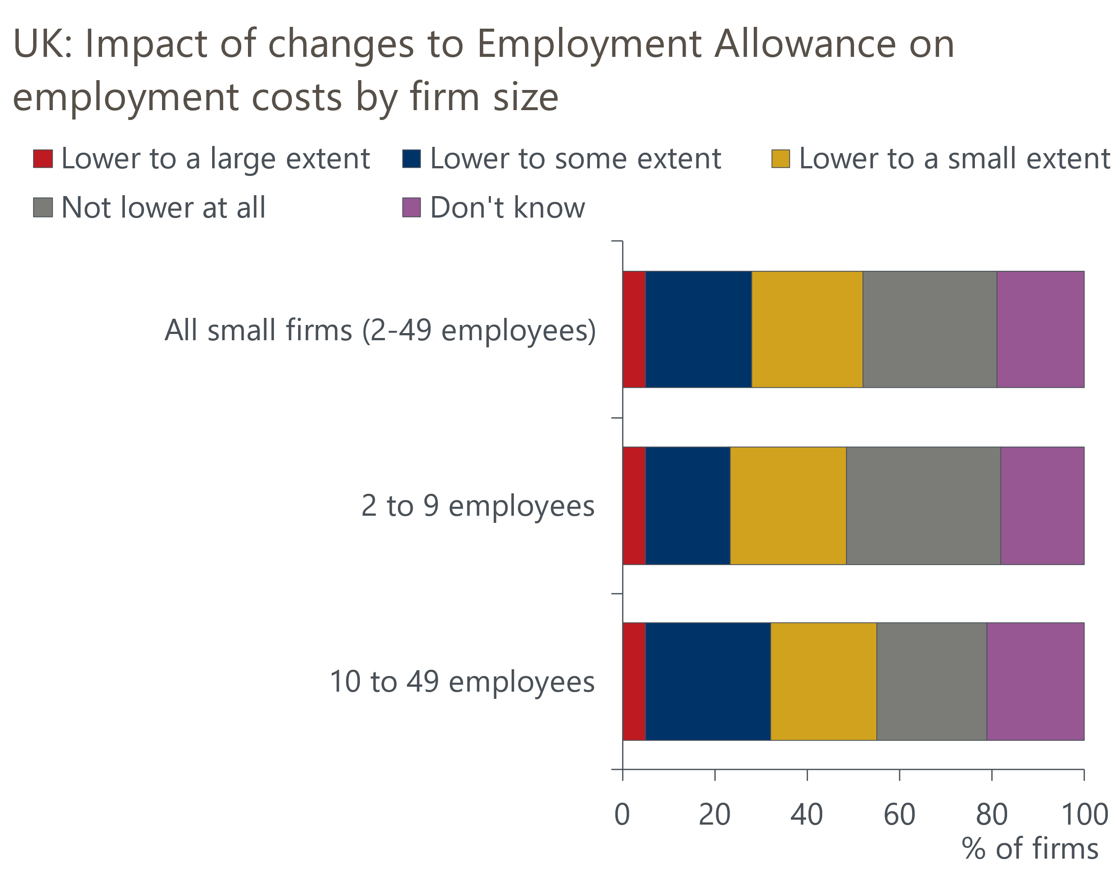
Source: CIPD
But equally, smaller firms took on large amounts of debt to get through the pandemic and were more exposed to the subsequent interest rate shock. Many have subsequently deleveraged, but with interest rates still relatively high and smaller firms tending to be more labour-intensive, we are particularly concerned about the ability of these firms to absorb another round of cost increases.

Our forecast assumes a much bigger impact on employment than our scenario implies
On balance, we think there's a good chance that the specific circumstances will give rise to a much bigger impact on employment than our simple model scenario implies. The combination of a simultaneous large rise in the NLW and big cut to the starting point for paying NICs is likely to have a disproportionate impact on lower-paid jobs, while the ability and willingness of firms to absorb further cost increases is likely to be limited after the struggles of the past few years.
The uncertainty around our baseline is high, and the problem of unusually noisy data that we identified previously is likely to make it much harder to judge the impact. Indeed, given the lags associated with data releases, it could be the autumn before we get a firm handle on how the labour market has responded.
If there is evidence of a greater labour market shakeout, then the earliest indication is likely to come from redundancy notices. The latest outturn is for the three months to December and shows the redundancy rate rising modestly compared with the previous three-month period but remaining well below historical norms. It's too soon for the Budget announcements to have affected the data published so far, but if the redundancy rate continues to pick up over the next couple of months, this could be an indication that the NICs rise will have a material impact on employment.

